Experiment 10 OOPS Lab

Collections

Name: Aditya Goyat

SAP ID: 500080575

1) Write a program for the following

* Read all elements from ArrayList by using Iterator.
* Create duplicate object of an ArrayList instance.
* Reverse ArrayList content.

CODE:

**package** exp10;

**import** java.util.*;

**public** **class** MainQ1 {

**public** **static** **void** main(String[] args) {

// **TODO** Auto-generated method stub

ArrayList<Integer> arr = **new** ArrayList<Integer>();

arr.add(1);

arr.add(2);

arr.add(3);

Iterator<Integer> itr = arr.iterator();

**while**(itr.hasNext()) {

System.***out***.println(itr.next());

}

System.***out***.println(arr);

Collections.*reverse*(arr);

System.***out***.println(arr);

ArrayList<Integer> arr1 = (ArrayList<Integer>) arr.clone();

System.***out***.println(arr1);

}

}

OUTPUT:

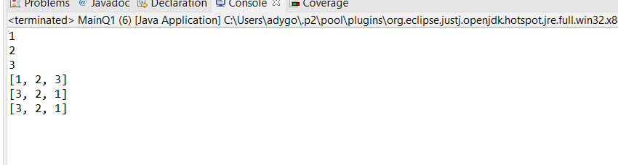

2) Write a program for the following HashMap

* find whether specified key exists or not.
* find whether specified value exists or not
* get all keys from the given HashMap
* get all key-value pair as Entry objects

CODE:

**package** exp10;

**import** java.util.*;

**public** **class** MainQ2 {

**public** **static** **void** main(String[] args) {

// **TODO** Auto-generated method stub

Scanner sc = **new** Scanner(System.***in***);

HashMap<Integer, String> map = **new** HashMap<Integer, String>();

map.put(1, "First");

map.put(2, "Second");

System.***out***.println(map);

**for**(Map.Entry<Integer, String> m: map.entrySet()) {

System.***out***.println(m.getKey() + m.getValue());

}

**for**(Integer m: map.keySet()) {

System.***out***.println(m);

}

System.***out***.print("Enter the key you want to search: ");

**int** k = sc.nextInt();

**if**(map.containsKey(k))

System.***out***.println("The key is present!");

**else**

System.***out***.println("The key is not present!");

System.***out***.print("Enter the value you want to search: ");

String v = sc.next();

**if**(map.containsValue(v))

System.***out***.println("The value is present!");

**else**

System.***out***.println("The value is not present!");

}

}

OUTPUT:

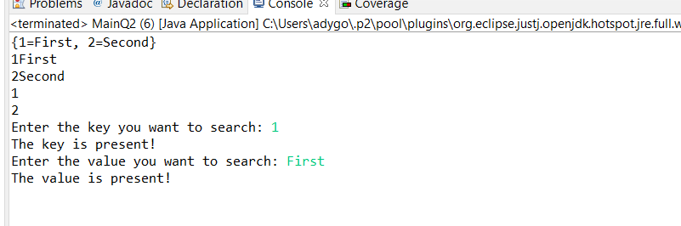

3) Write a program for the following HashSet

* copy another collection object to HashSet object.
* delete all entries at one call from HashSet
* search user defined objects from HashSet

CODE:

**package** exp10;

**import** java.util.*;

**public** **class** MainQ3 {

**public** **static** **void** main(String[] args) {

// **TODO** Auto-generated method stub

HashSet<Integer> set = **new** HashSet<Integer>();

HashSet<Integer> set1 = **new** HashSet<Integer>();

Integer i = **new** ~~Integer~~(7);

set.add(1);

set.add(2);

set.add(2);

set1.add(3);

set1.add(4);

set.add(i);

set.addAll(set1);

System.***out***.println(set);

Iterator<Integer> itr = set.iterator();

**while**(itr.hasNext()) {

System.***out***.println(itr.next());

}

**if**(set.contains(i))

System.***out***.println("The set contains the user defined object!");

set.clear();

}

}

OUTPUT:

